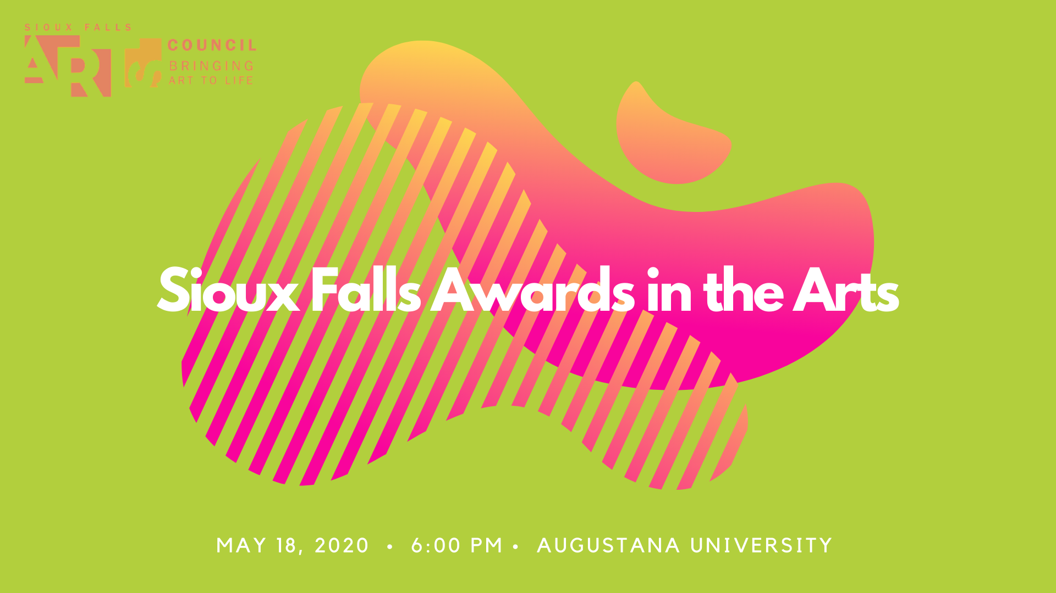

Nomination Form

Nominations accepted through April 24, 2020

Ceremony and Reception:
May 18, 2020 6 to 8 PM
Augustana University Humanities Center

The public is invited to nominate candidates for awards in the following categories:

- Individual Excellence Awards for Artists
Recognizes individual performing, music, visual or literary artists whose contributions have raised the bar in their artistic specialty, made an impact on the professional development of other artists or forged new paths in connecting their work to the community.

- Forward Arts Award
Honors an organization or business which has helped move education, creation or awareness of the arts forward in our community.

- Innovative Project Award
Recognizes a project characterized by meaningful partnerships between or among private businesses, public bodies, individual artists, and organizations. This award seeks to recognize partnerships that created a new way for the community at large to experience the arts.

- Charlotte Carver Award for Lifetime Achievement in the Arts
Named for the first Executive Director of the South Dakota Arts Council and a long-time advocate and friend of the arts in Sioux Falls, this award honors an individual or organization that has demonstrated an enduring, long-term dedication to the arts.

***

Nominee’s name:

Award category:

- Nominee’s short bio (if individual) or historic summary (if organization or business):

- Nomination statement (why the nominee should receive this award – approximately 500 words):

- Please attach supporting images, documents, URL’s, news stories or statements you wish to include for consideration via email attachments when submitting to amford@artssiouxfalls.org, or by mail.

Your information if the selection committee needs to reach out with any questions regarding this nomination:

Name:

Telephone:

Email:

Organizational Affiliation (if any):

***

Submit nominations via email at amford@artssiouxfalls.org or by mail at Sioux Falls Arts Council, 326 E. 8th St #106AB, Sioux Falls, SD 57103.

Nominations will be accepted through April 24, 2020.

For more information, call the Sioux Falls Arts Council at 605.271.6696.

