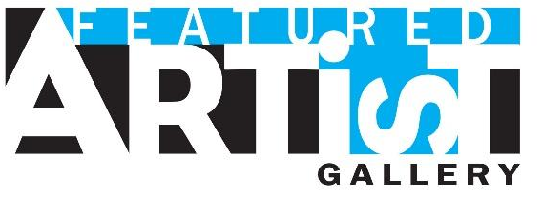
Call for Artists – 2020 Featured Arts Exhibit Sioux Falls Arts Council Community Gallery
Crane Centre @ 8th & Railroad

Eligibility
Local artists who live or work in the Greater Sioux Falls Area (Minnehaha, Lincoln, McCook and Turner Counties).

Rotating Exhibit
The exhibit will rotate on a quarterly basis. Submissions from this Call for Art will be used to select artists for all 2020 rotations.
- January & February 2020
- March & April 2020
- May & June 2020
- July & August 2020
- September & October 2020
- November & December 2020

Submission Process
All submissions must be done on our website www.artssiouxfalls.org or by emailing amercado@artssiouxfalls.org

Timeline
Submission Deadline: December, 21, 2016
Selections Announced: November 28, 2016

Entry Fees
None

Sales
Your work may be listed for sale while it is on exhibit at the Sioux Falls Arts Council. All sales transactions will be conducted directly between the artist and the purchaser. Sold pieces may not be removed until your exhibit rotation is complete. The Sioux Falls Arts Council will not collect any commissions. A donation back to the Arts Council is encouraged, but not required.

Sioux Falls Arts Council will:
- host an Artist Reception on First Friday of the first month of your rotation.
- print informational brochures, which will include your artist biography, contact information, and images of your work.
- feature you on the home page of ArtsSiouxFalls.org for the duration of your exhibit. (Once your exhibit has ended, your information will move to the Featured Artist page of the website.)
- promote your exhibit on social media and online calendar.
- be open Monday-Friday 10:00 am – 4:00 pm, every First Friday 5:00 – 7:00 pm and by appointment.

Selected artists will:
- review and sign an Agreement & Release.
- install their work between the 25th and the end of the month prior to their exhibit opening.
- provide signage for each piece, including title and price.
- remove their work by the 20th of the last month of their exhibit.

Sioux Falls Arts Council • 326 E 8th St #106A, Sioux Falls, SD 57103 • 605-271-6696 info@artssiouxfalls.org • www.artssiouxfalls.org

