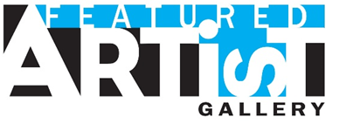

2018 Featured Artist Exhibit Sioux Falls Arts Council Gallery

Eligibility
Local artists who live or work in the Greater Sioux Falls Area (Minnehaha, Lincoln, McCook and Turner Counties).

Contact Information

First Name:

Last Name:

Address:

City:

State:

Zip:

County:

Phone:

Email:

Website:

Artist Information

Please attach via email to amercado@artssiouxfalls.org:

- A biography or resume including education, awards, other exhibits

- Artist statement including the medium(s) you use, what inspires your work, and what it means to you.

(Word or PDF formats accepted)

Images

Attach a minimum of 10 and maximum of 15 images of your work via email to: amercado@artssiouxfalls.org

Only submit images that represent a cohesive body of work to be exhibited together
(JPG format accepted here)

Sales

Your work may be listed for sale while it is on exhibit at the Sioux Falls Arts Council. All sales transactions will be conducted directly between the artist and the purchaser. Sold pieces may not be removed until your exhibit rotation is complete. The Sioux Falls Arts Council will not collect any commissions.

Sioux Falls Arts Council will:

- host an Artist Reception on First Friday of the first month of your rotation.
- print informational brochures, which will include your artist biography, contact information, and images of your work.
- feature you on the home page of ArtsSiouxFalls.org for the duration of your exhibit. (Once your exhibit has ended, your information will move to the Featured Artist page of the website.)
- promote your exhibit on social media and online calendar.
- be open Monday-Friday 10:00 am – 4:00 pm, every First Friday 5:00 – 7:00 pm and by appointment.

Sioux Falls Arts Council • 326 E 8th St #106A, Sioux Falls, SD 57103 • 605-271-6696 info@artssiouxfalls.org • www.artssiouxfalls.org

